**Event Study on Activision Blizzard (ATVI)**

By: Andrew Khoury, Jorge Mendez, and Wassef Abouelchabab

On January 18, 2022, Microsoft unexpectedly announced its intention to acquire Activision Blizzard (ATVI) in an all-cash transaction valued at approximately $68.7 billion. The size of the acquisition and the substantial amount offered marked a significant strategic move by Microsoft into the emerging gaming sector. Given the unexpected nature of the announcement and the premium over the prevailing market price of Activision Blizzard’s stock, it was anticipated that this event would positively impact Activision Blizzard’s stock returns. This study aims to determine whether the market’s reaction to this acquisition announcement led to abnormal returns for Activision Blizzard shareholders. This analysis uses statistical methodologies, including t-test, regression models, and abnormal return computations to assess the announcement’s financial implications.

**Event and Estimation Windows**

The event being studied was publicly announced on January 18, 2022, marking the event date. To effectively measure the market’s reaction, we defined two periods known as the estimation window and an event window. The estimation window covered the period from July 1, 2021, to January 10, 2022. We chose this approximately six-month duration was selected because it showed us enough historical data to reflect Activision Blizzard’s normal stock performance under stable market conditions. We removed outliers that were caused by other events that would impact our typical stock performance. Additionally, the estimation window concluded one week prior to the event date to make sure that potential pre-announcement leakage would not misrepresent the estimation of normal returns.

The event window was established from January 11, 2022, to January 28, 2022. This window includes 4 days prior to the official announcement date, allowing the capture of any potential early market anticipation or information leakage. Extending the window 8 days after the announcement also allowed the analysis to consider both immediate and delayed investor responses, which will provide a detailed assessment of the event’s impact on Activision Blizzard’s stock return.

**Data Collection**

Daily stock prices for Activision Blizzard (ATVI) were collected to calculate daily stock returns. The daily returns of the S&P 500 index were used as a proxy to compare overall market returns (RM). The risk-free rate (RF) was obtained from the U.S. 10-Year Treasury Constant Maturity Rate published by the Federal Reserve Bank of St. Louis (FRED). Additionally, the ESPO ETF (an eSports and gaming-focused ETF) was included to account for sector-specific movements related to the gaming industry.

Daily Returns were computed using the formula:

$$Return_{t}=\frac{\left(P_{t}- P_{t-1}\right)}{P_{t-1}}$$

where $Return_{t}$ represents the return at day $t$, $P_{t}$ is the closing price on day $t$, and $P_{t-1}$ ​ is the closing price on the previous trading day.

**Stock Price Analysis**

The figures below show the daily closing prices and daily returns of Activision Blizzard (ATVI) from July 1, 2021, to January 28, 2022. Prior to January 18, 2022, ATVI’s stock price exhibited a declining trend, showing ongoing challenges within the company. Following the announcement of Microsoft’s acquisition on January 18,2022, a noticeable surge in stock price is observed, indicating a strong positive market reaction.

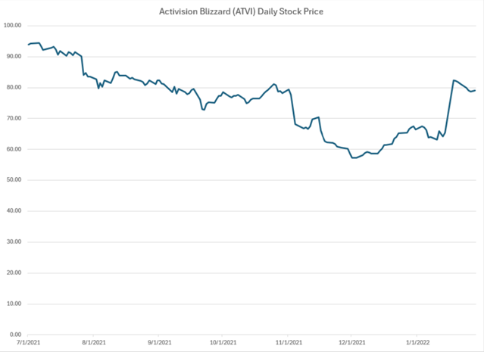

The daily returns graph also shows a large positive spike on the event date, with returns exceeding 25%. This substantial abnormal return suggests that the market responded very favorably to the acquisition news, confirming the hypothesis that the event had a significant positive impact on ATVI’s stock performance.

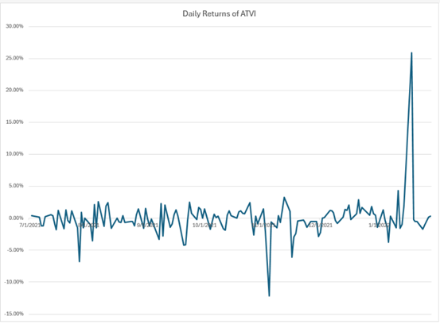

Overall, the graphs shown as evidence strongly suggests that the market reacted immediately and positively to the acquisition announcement, supporting the presence of abnormal return.

**Descriptive Statistics**

The descriptive statistics for Activision Blizzard’s (ATVI) daily returns during the estimation period from July 1, 2021, to July 10, 2022, are shown below:

| **Statistic** | **Value** |
| --- | --- |
| Mean | -0.0028 |
| Standard Deviation | 0.0197 |
| Minimum | -0.1215 |
| Maximum | 0.0324 |
| Count | 132 |
| Skewness | -2.1666 |

The average daily return was approximately -0.28%, showing a slight negative trend in the stocks’ performance under normal market conditions. The standard deviation of 1.97% shows moderate volatility in daily returns. The minimum daily return of -12.15% and maximum return of 3.24% show occasional large price movements even outside major events. The distribution of returns is negatively skewed (skewness of -2.17), suggesting that losses were generally larger and more extreme than gains during this period. A total of 132 daily return observations were collected for the estimation window. Observations related to the event window (January 11, 2022 – January 28, 2022) will be analyzed separately.

**Methodology**

This study will use several statistical methods to evaluate whether the announcement of Microsoft’s acquisition of Activision Blizzard resulted in abnormal stock returns. Statistical analyses were conducted to detect and measure abnormal returns associated with the event, where each method provides a different approach to estimating the expected returns and assessing the potential abnormal returns. The methodologies used include a simple mean return test, the market model regression, the Capital Asset Pricing Model (CAPM), and a multifactor regression analysis.

**Two-Sample t-Test for Mean Differences**

To determine whether the announcement of Microsoft’s acquisition of Activision Blizzard had a significant impact on stock returns, a two-sample t-test assuming equal variances was used. This test compares the average daily returns observed during the pre-event estimation window to the average daily returns during the event window, which provided a statistical evaluation of whether the event produced abnormal returns outside of normal market behavior. The hypothesis for our test is: The null hypothesis ($H_{0}$) states that there is no difference between the mean returns of the estimation window and event window. The alternative hypothesis ($H_{a}$) states that there is a statistically significant difference between the two means, indicating the presence of abnormal returns. The t-test yielded a t-statistic of -2.7226, while the critical values at the 5% significance level for a two-tailed test with 143 degrees of freedom were approximately ±1.9767.

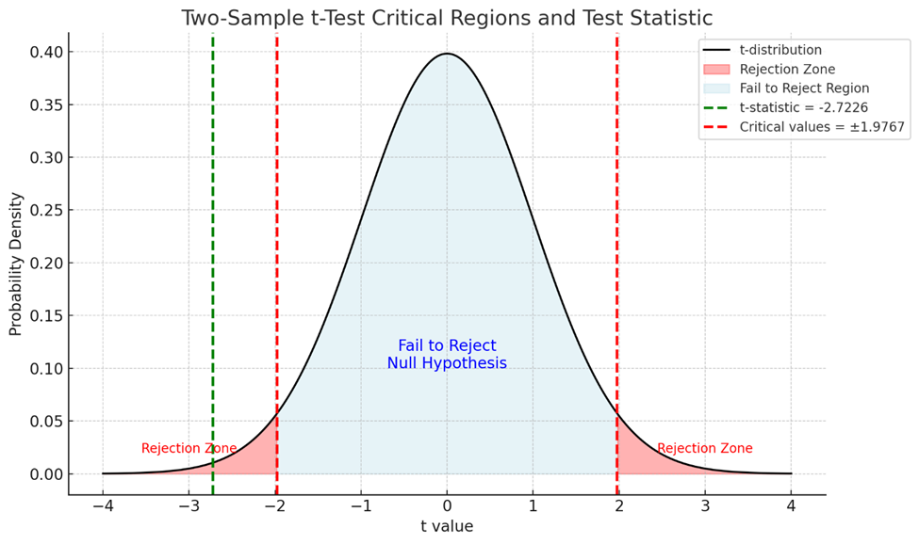

Since the calculated t-statistic falls beyond the negative critical value, the null hypothesis was rejected. Additionally, the two-tailed p-value that resulted from the test was 0.0072, which is lower than both the 5% and 1% significance levels, providing strong evidence against the null hypothesis. The results suggest that the mean returns during the event window were significantly different from the mean returns during the estimation period. This statistical significance supports the hypothesis that the announcement of Microsoft’s acquisition of Activision Blizzard had an impact on the ATVI stock price, showing the market’s strong reaction to the event.

**CAPM Model Estimation**

In addition to the t-test, a Capital Asset Pricing Model (CAPM) regression was conducted to estimate expected returns during the event window. The CAPM model relates the return of a stock to the return of the overall market, adjusted by the risk-free rate, and is expressed by the following equation:

$$E\left(R_{i}\right)= α+ β\left(R_{m}- R_{f}\right)$$

where $R_{i}$ ​ is the return of Activision Blizzard, $R_{m}$ ​ is the return of the market (S&P 500), $R_{f}$ is the risk-free rate (10-year U.S. Treasury yield), $α$ is the intercept of the regression, $β$ is the slope coefficient measuring sensitivity to the market excess return, and $ϵ$ is the error term, which is assumed to have an expected value of zero.

The CAPM regression produced an intercept ($α$) of -0.0085 with a p-value of 0.0030, and a slope coefficient ($β$)of 0.5500 with a p-value of 0.0021. Both coefficients were statistically significant at the 1% level, indicating that the model’s parameters were meaningful predictors of stock return behavior during the estimation period. The $R^{2}$ value was 7.02%, suggesting that while broader market movements explained a portion of Activision Blizzard’s returns, additional factors also influenced the stock’s performance. The cumulative abnormal return (CAR) over the event window was approximately +29.10%, indicating a substantial positive reaction by the market to Microsoft's acquisition announcement. Overall, the CAPM model findings support the presence of statistically significant abnormal returns, reflecting both broader market effects and company-specific influences linked to the acquisition event.

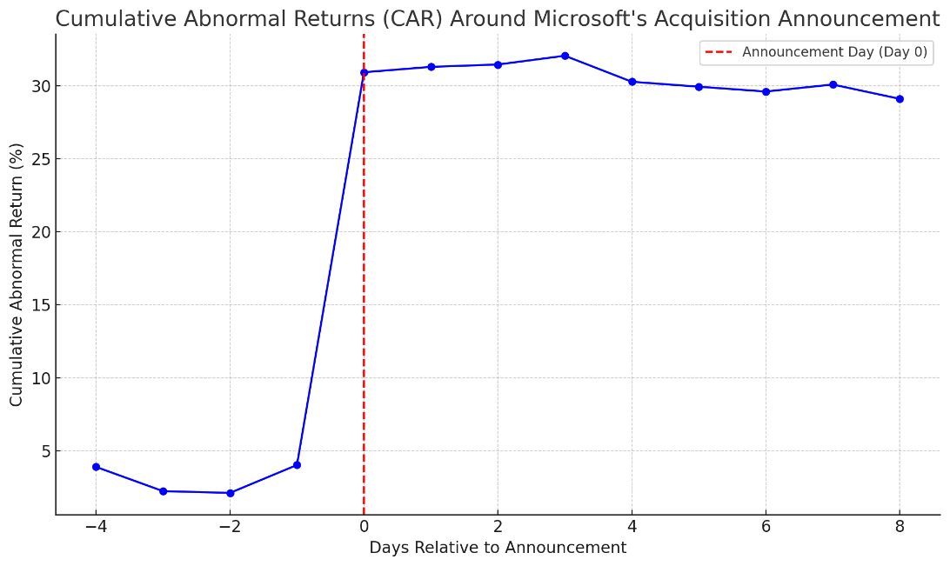

**Multifactor Regression Estimation**

To better capture sector-specific influences alongside market-wide movements, a multifactor regression was conducted. In addition to the market excess return, the model included the returns of the ESPO ETF, which tracks gaming and eSports companies, as an explanatory variable. The regression is expressed as:

$$E\left(R_{i}\right)=α+β_{1}\left(R_{m}-R_{f}\right)+β_{2}\left(R_{ESPO}\right)+ϵ$$

Where $E_{ESPO}$ the daily returns of the ESPO ETF.

The multifactor regression produced an intercept ($α$) of -0.0118 (p = 0.4201), a market factor coefficient ($β_{1}$ ​) of 0.7134 (p = 0.4797), and a sector factor coefficient ($β_{2}$ ​) of 0.3071 (p = 0.0013). Only the sector factor was statistically significant at the 1% level, indicating that the ESPO returns were a meaningful predictor of Activision Blizzard’s stock movements during the estimation period. The $R^{2}$ value of the model was 8.25%, showing a slight improvement compared to the single-factor CAPM model. The cumulative abnormal return (CAR) over the event window remained approximately +29.10%, further supporting the conclusion that the acquisition announcement produced significant abnormal returns.

**Interpretation and Conclusion**

This event study analyzed the impact of Microsoft's acquisition announcement on Activision Blizzard’s stock returns using a combination of statistical techniques, including a two-sample t-test, a CAPM regression, and a multifactor regression incorporating sector-specific factors. The results from the two-sample t-test indicated a statistically significant difference between the mean returns of the estimation and event windows, suggesting the presence of abnormal returns surrounding the announcement date. The CAPM regression further confirmed the existence of abnormal returns, with both the intercept and the market sensitivity coefficient ($β$)being statistically significant at the 1% level. Although the CAPM model explained only about 7% of the variation in returns ( $R^{2}$ =0.0702), the large cumulative abnormal return (CAR) of approximately +29.10% strongly indicated a substantial positive market reaction. The multifactor regression, which incorporated returns from the ESPO gaming ETF, showed that sector-specific influences contributed meaningfully to Activision Blizzard’s return behavior. In this model, the ESPO factor was statistically significant, while the broader market factor and the risk-free rate were not, highlighting the importance of industry dynamics in explaining the stock’s reaction to the event. In conclusion, the evidence consistently supports the view that Microsoft's acquisition announcement generated significant positive abnormal returns for Activision Blizzard shareholders. Both broader market trends and sector-specific movements, particularly within the gaming industry, played important roles in shaping investor reactions to the event.